New Graduate Residency FAQs

- How do I upload my letters of recommendation and other documents?
- If you have just submitted your application:
Click on three dots -> Click on ‘My Job Applications’- > Click on ‘Add Attachment’
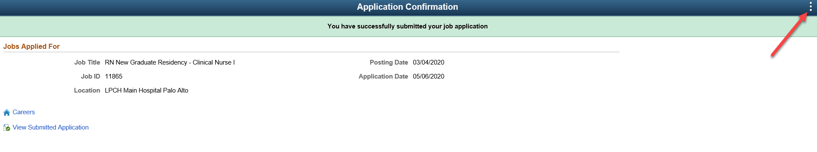
- If you have logged off:
Go to https://applyjobs.lpch.org -> Log on with the same userid/password which you created and used to apply to the position
Click on ‘My Job Applications’- > Click on ‘Add Attachment’
- I am having technical difficulties applying online. What should I do?
- If you are not located from within the United States, our system is not able to accept your application. You must be physically located in the United States to apply.
- Our system accepts all browsers (IE, Chrome, Safari).
- Pop-ups: If the application form is not opening on your computer, or you are not able to get the system to allow you to apply, you may have pop-up blocking software on your computer that is blocking the form from opening.
Our application opens in a new window. You must allow pop-ups on your browser to successfully apply.

- I have tried all of these things, and I still can’t apply!
If you have tried all of the suggestions in #2 and you still cannot apply, please email your resume, cover letter, transcripts and letters of recommendation to dali@stanfordchildrens.org. In the subject line, please put: "New Graduate Application Technical Difficulties" and include a description of the problem in your email. Make sure to include your contact information. We will get back to you within 1-3 business days.
- I do not have my letters of recommendation ready? Can I still apply?
We recommend waiting until you have all of your documentation ready before starting our application.
However, if you are close to our application deadline and you are still waiting for letters of reference, please apply online. You can email your remaining documents to dali@stanfordchildrens.org. If your application is not complete by this date, you will not be considered for our program.

